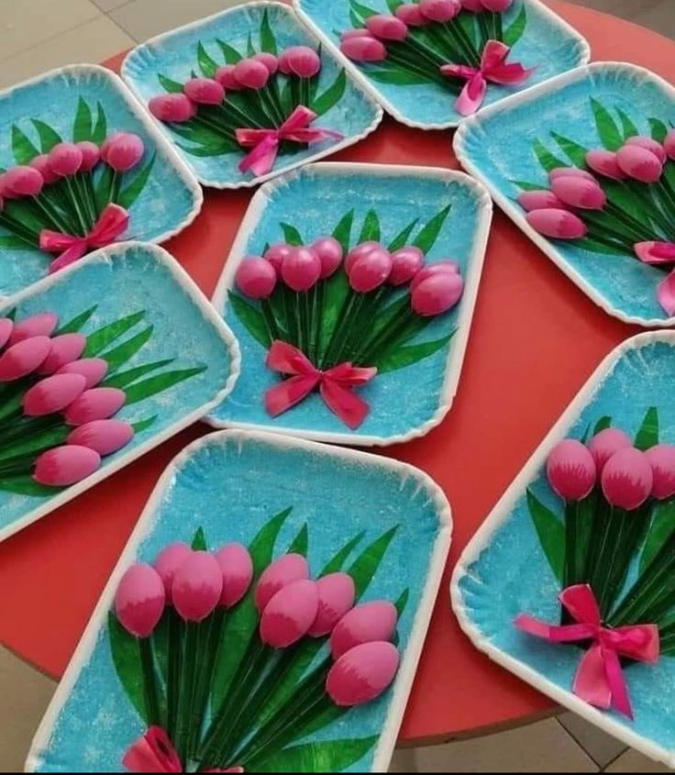
Instructions-
You will need- Paper plate
Paint brush
Various coloured paint. Acrylic works best on the flowers. You can
also use permanent markers for the flowers and textas for the background if you don’t have paint.
Plastic spoons
Ribbon
Pencil
Glue
Step one- Using the pencil, draw some leaves on the paper plate.
Step two- Paint/ colour in the leaves and the background on the plate
Step three- Turn the spoons over so the round part is facing upwards and paint
them/ colour them in however you’d like. Paint/colour the stalks in green.
Step four- When all the paint dries, assemble the flowers in a bouquet on top
of the leaves and use the ribbon to make a bow.
Step five- Use the glue to stick the spoons onto the plate and the ribbon onto
the spoons.

